
ASSIGNMENT NO 01
COURSE CODE:
SE-201.
COURSE TITLE:
DATA STRUCTURE (LAB).
SUBMITTED TO:
PROF MUHAMMAD SABEEH.
SUBMITTED BY:
MAHAM AMJAD.
25021598-126.
TITLE:
ARRAY, STACK AND QUEUE.

QUESTION NO 01:
Array Operations
Scenario: A small library wants a simple program to manage the list of book IDs currently on shelf. The shelf can hold a limited number of books at a time. The librarian needs a menu to manage this list from the console.
Code:
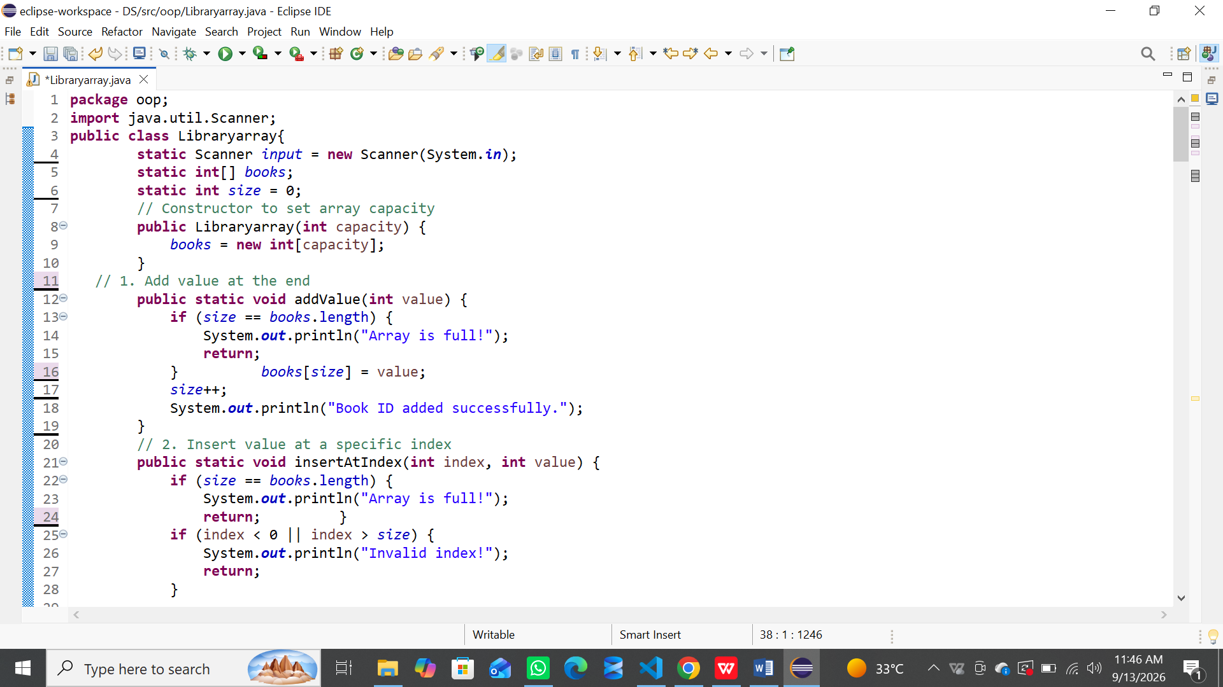
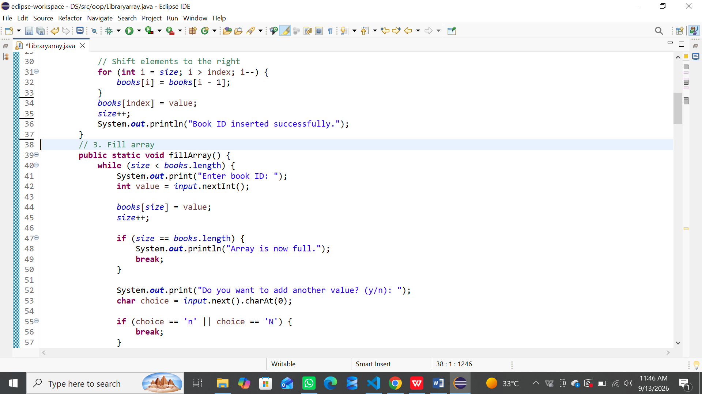
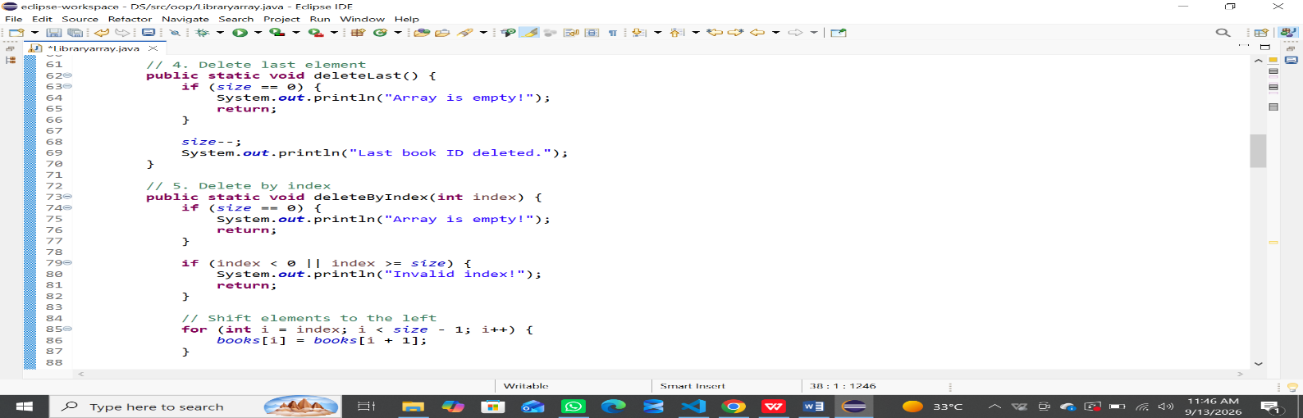
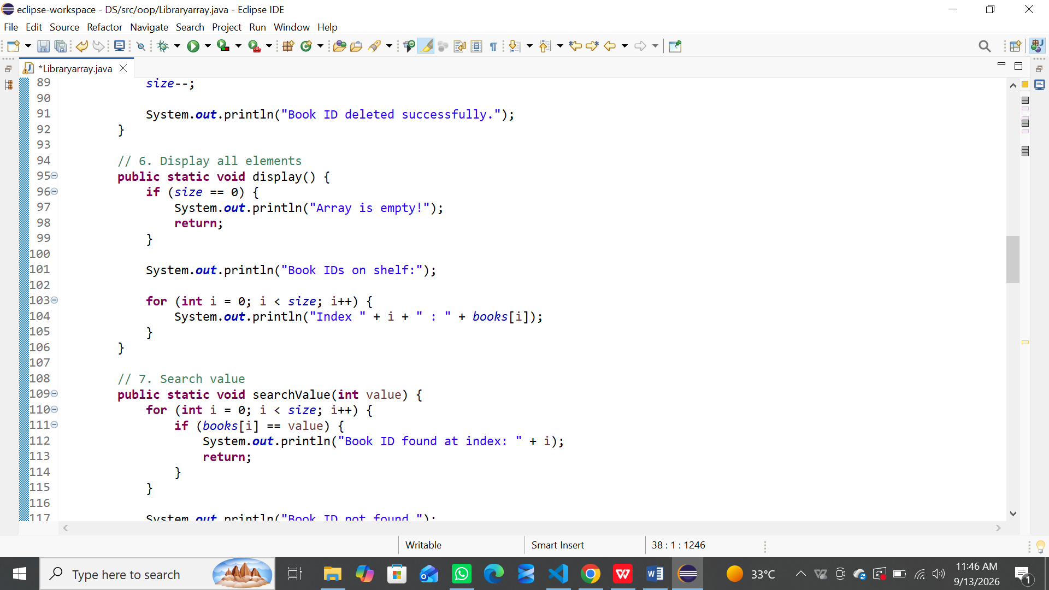
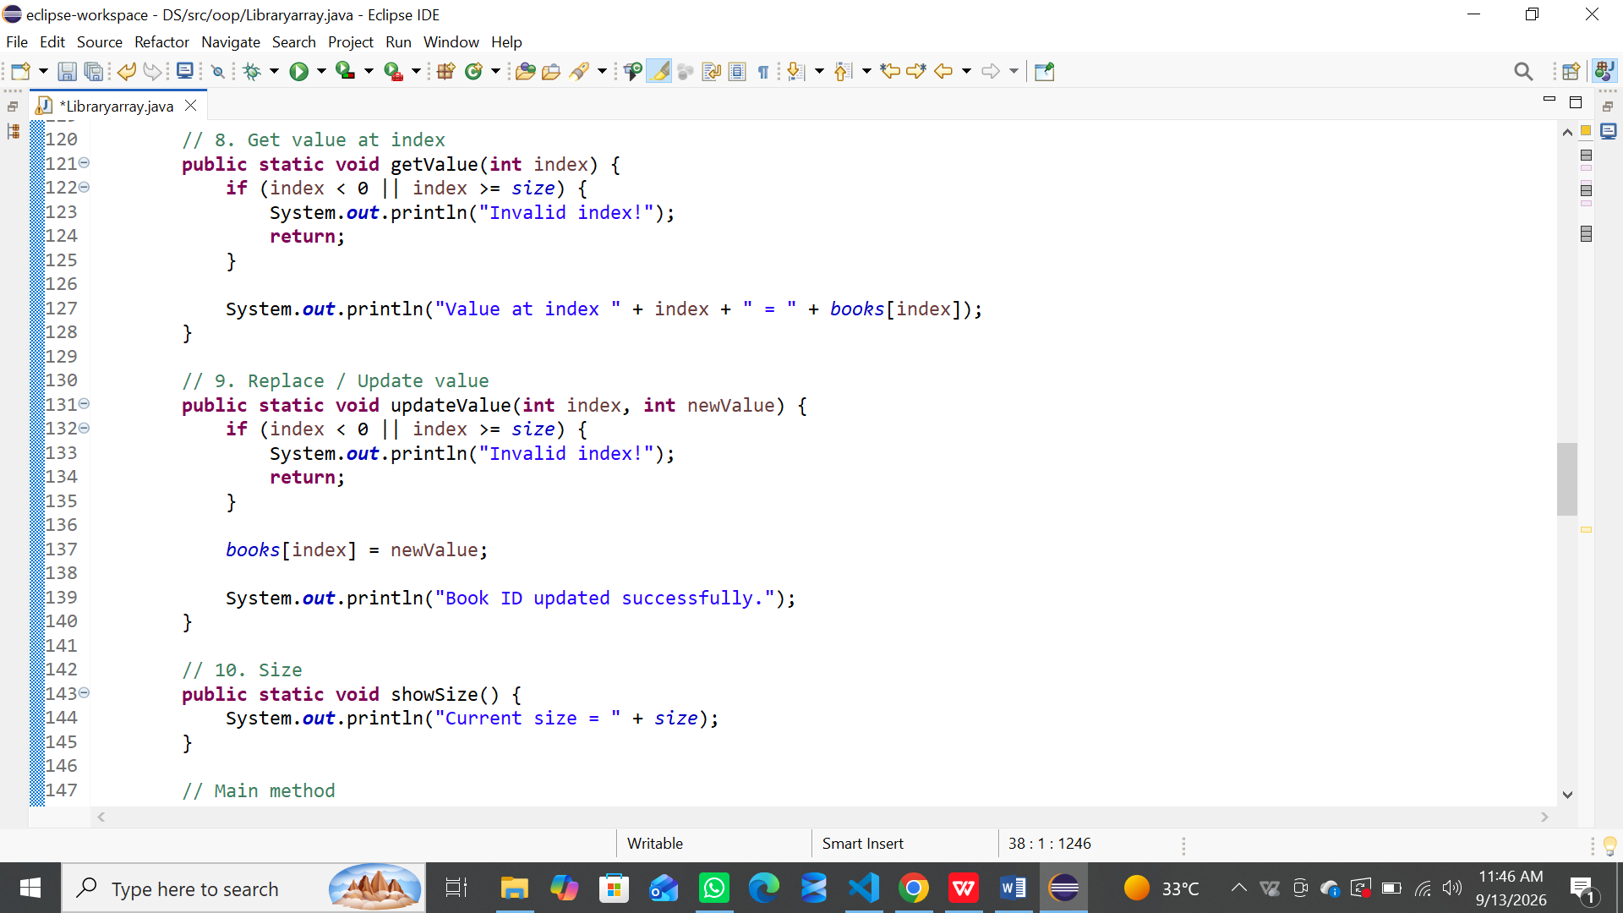
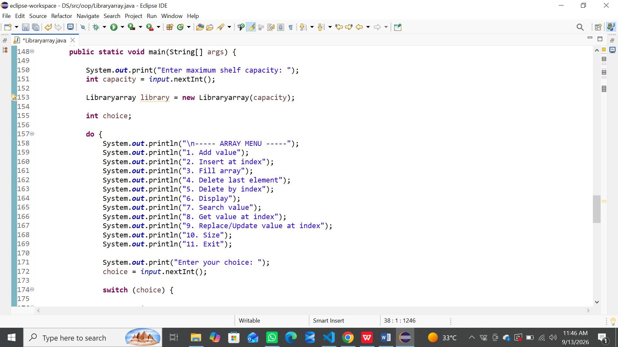
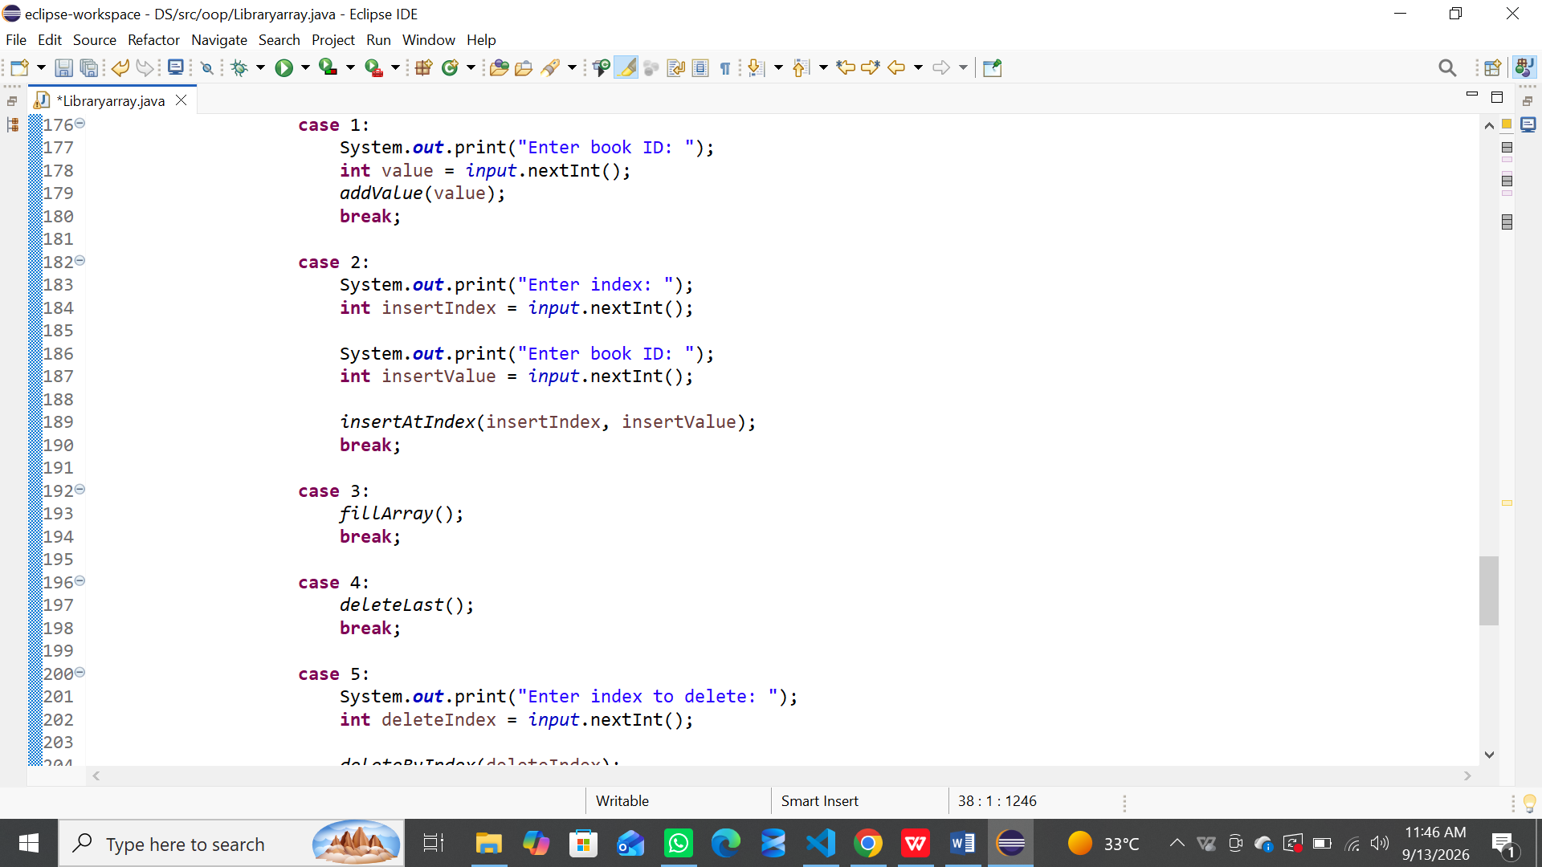
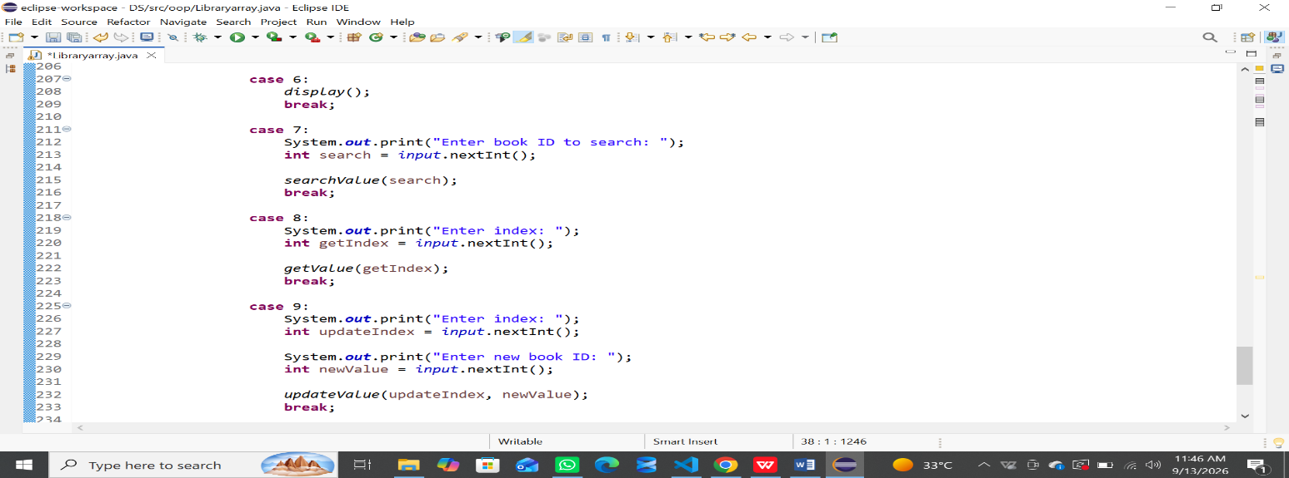
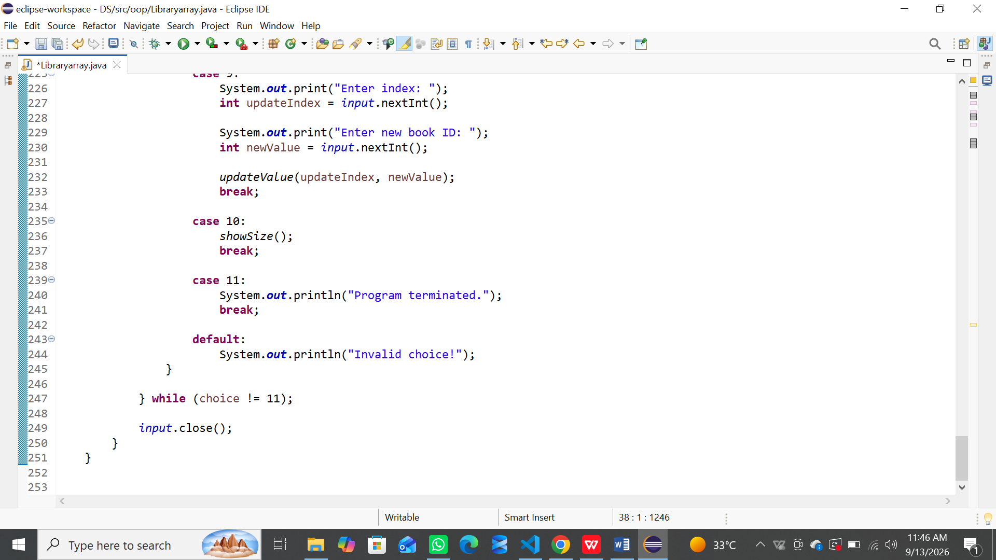
OUTPUT:
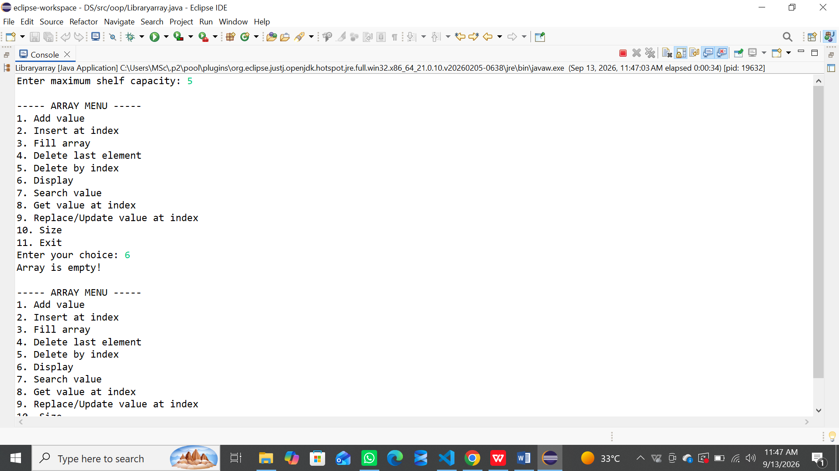
QUESTION NO 02:
Stack Operations
Scenario: You have a pile of plates (whole numbers written on each plate) stacked one on top of another. You can only add a new plate on top, and you can only remove the plate that is currently on top. Build a program to simulate this stack of integer values.
CODE:
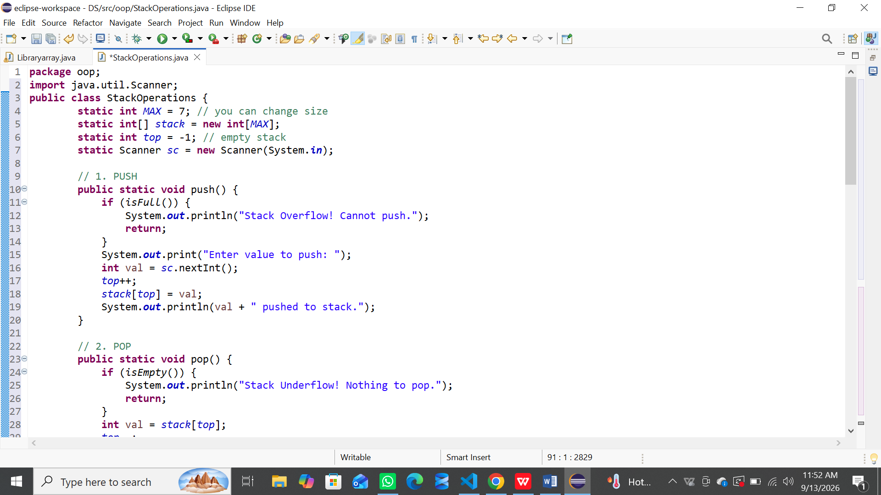
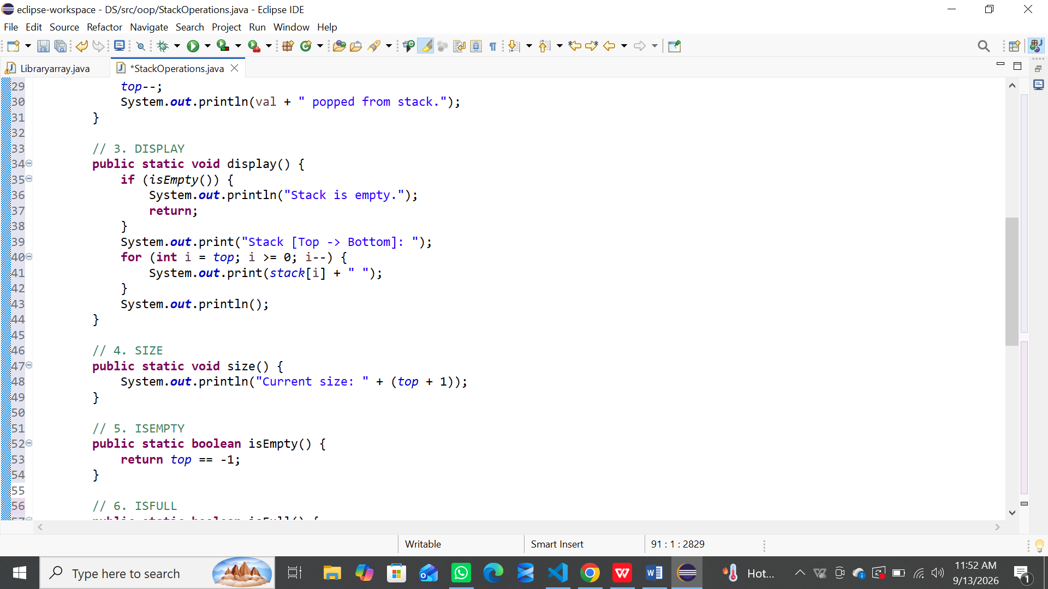
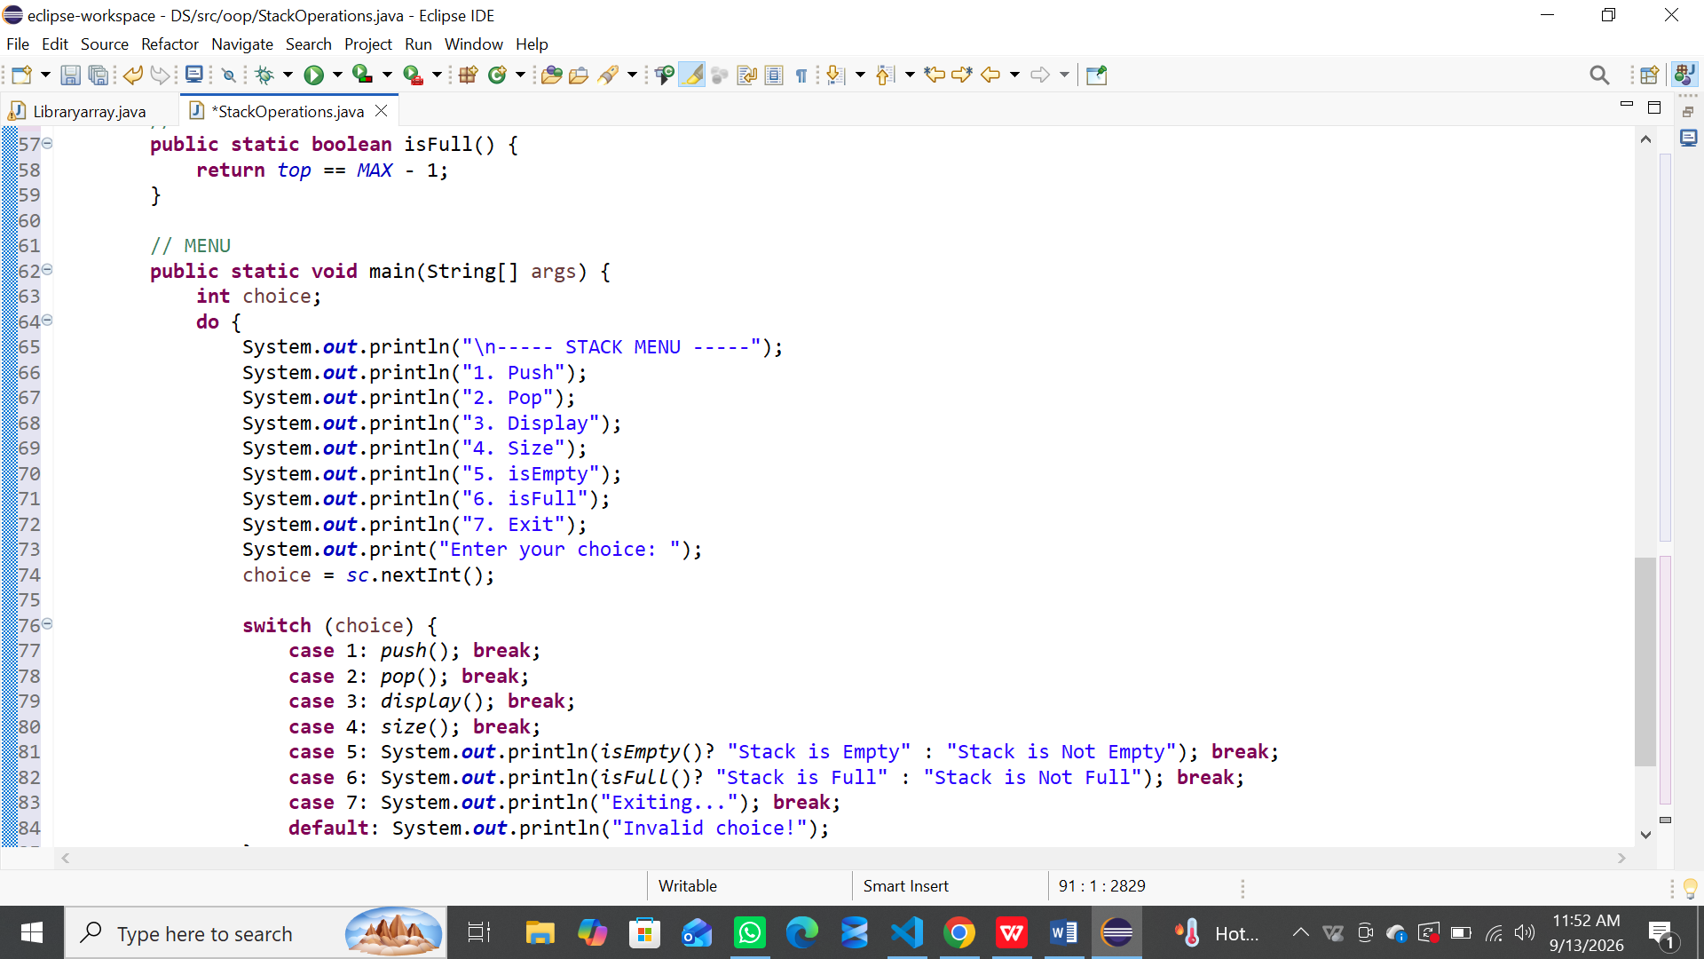
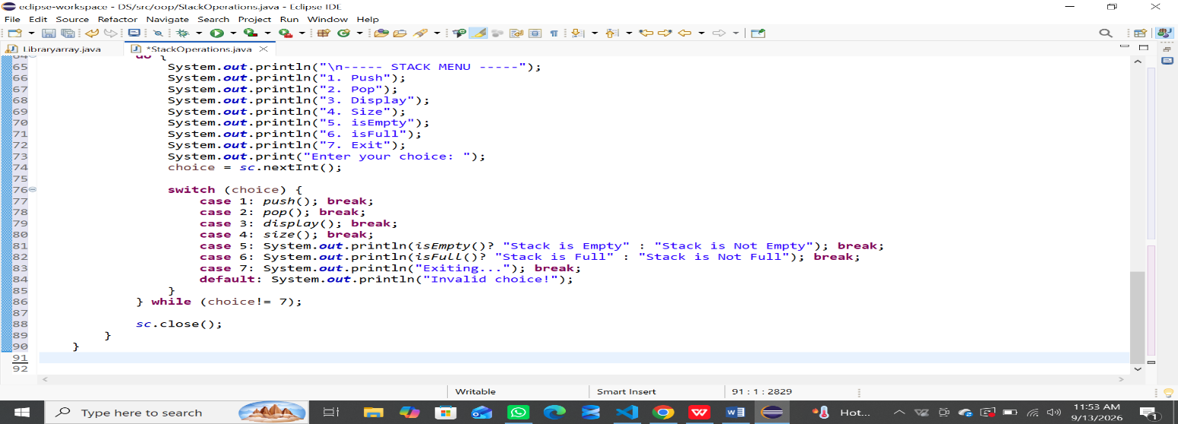
OUTPUT:
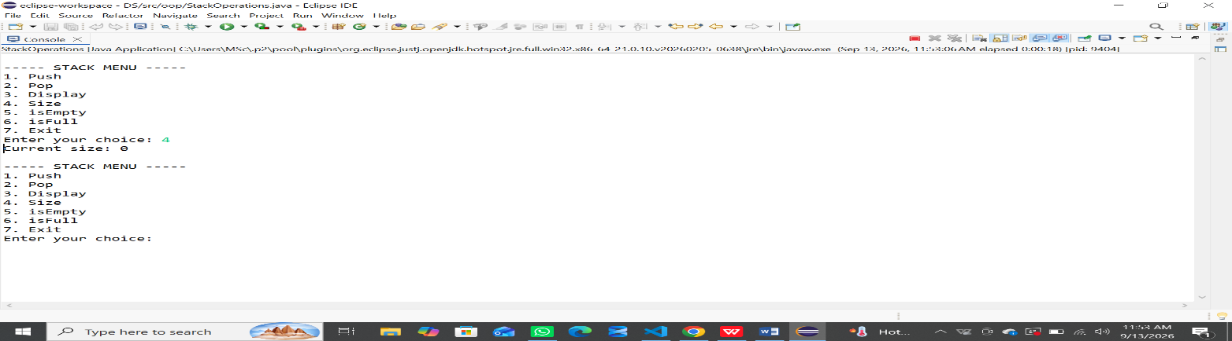
QUESTION NO 03:
Queue Operations
Scenario: A small bank counter serves customers using token numbers (integers). Every arriving serves the token at the front of the queue first. Build a program to manage this queue of integer token numbers.
CODE:
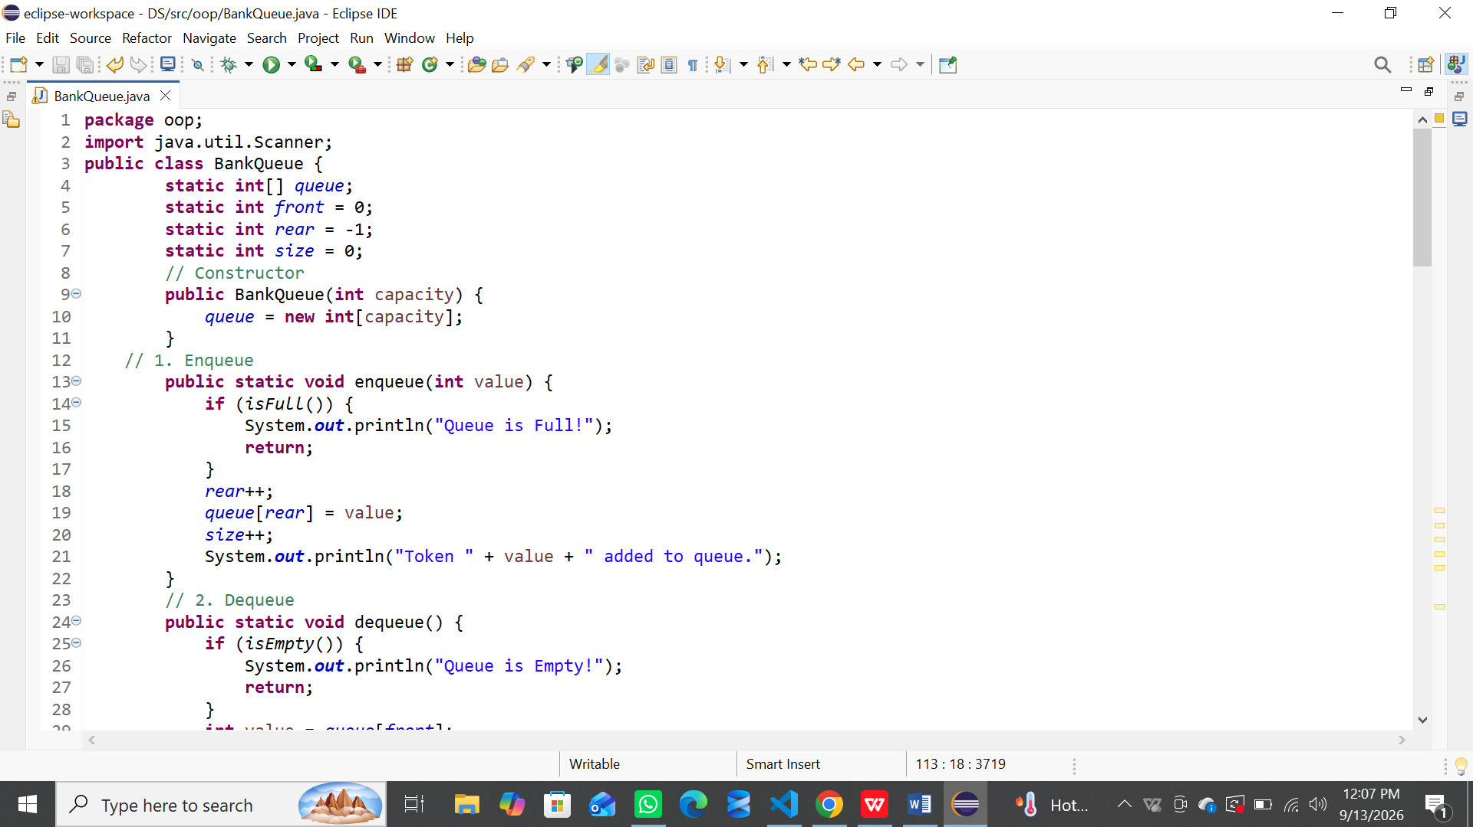
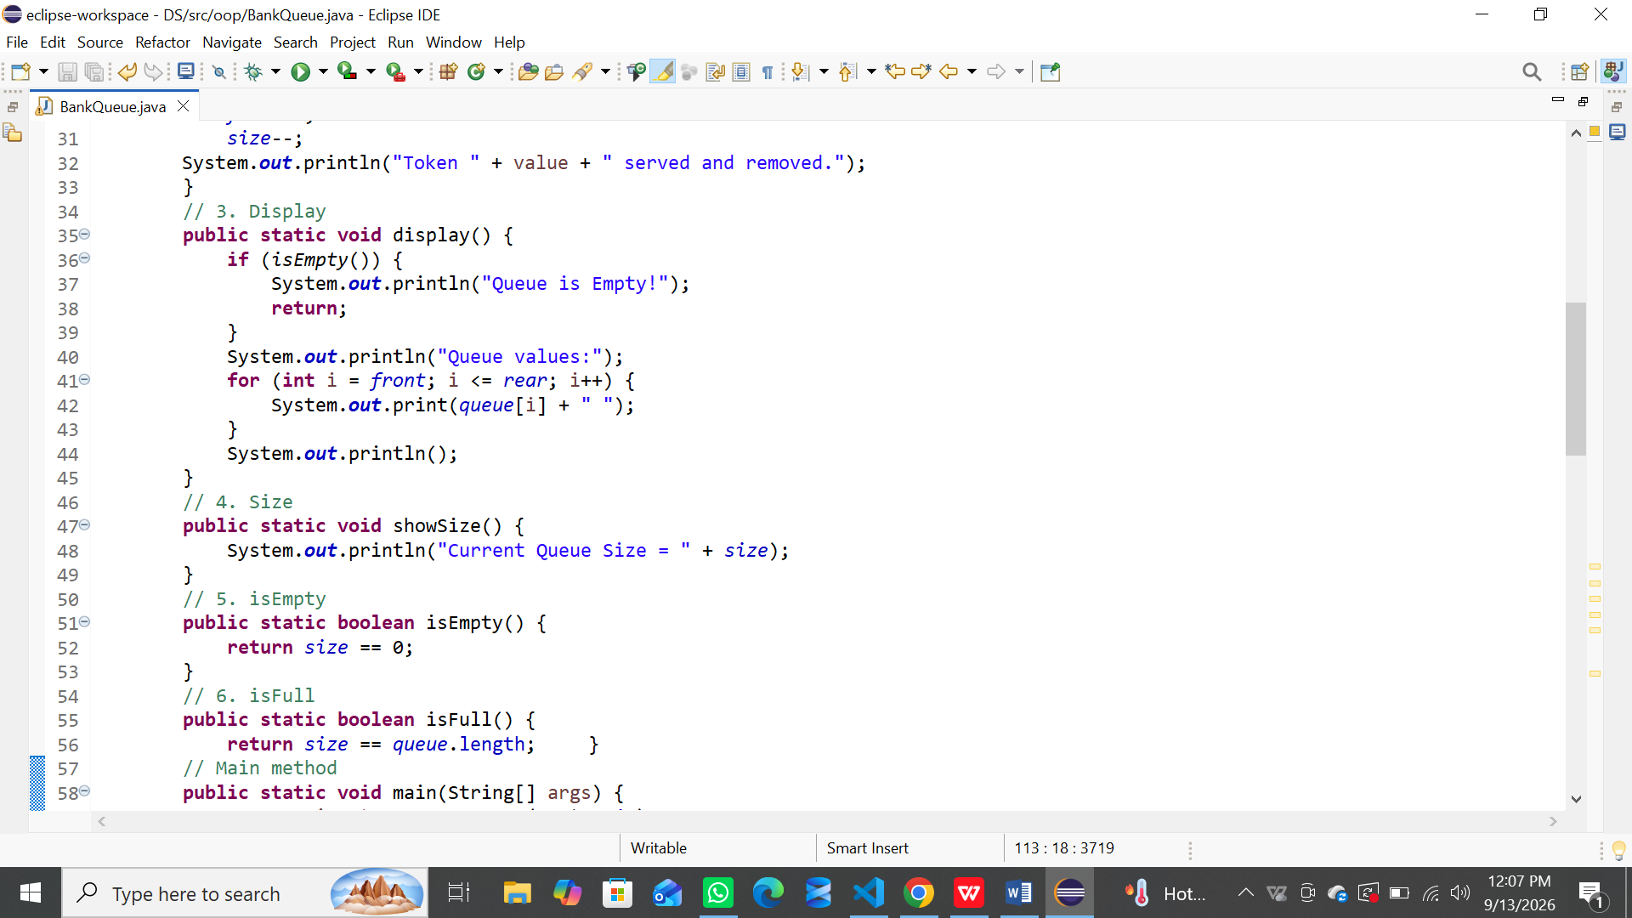

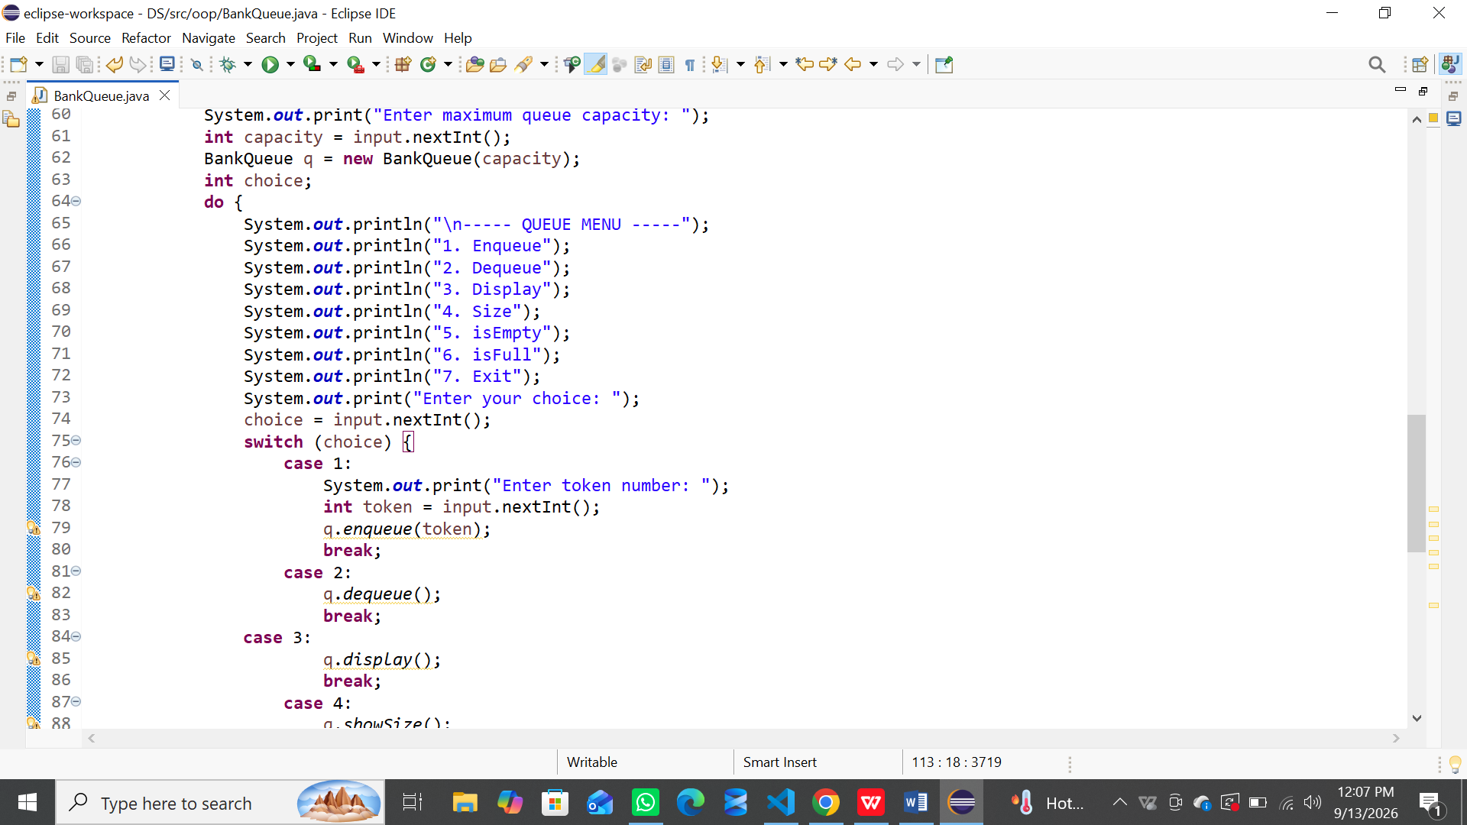
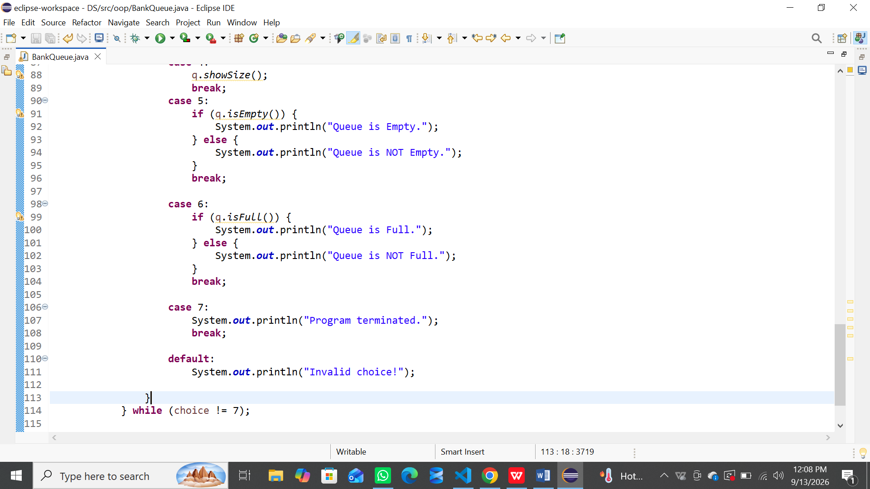
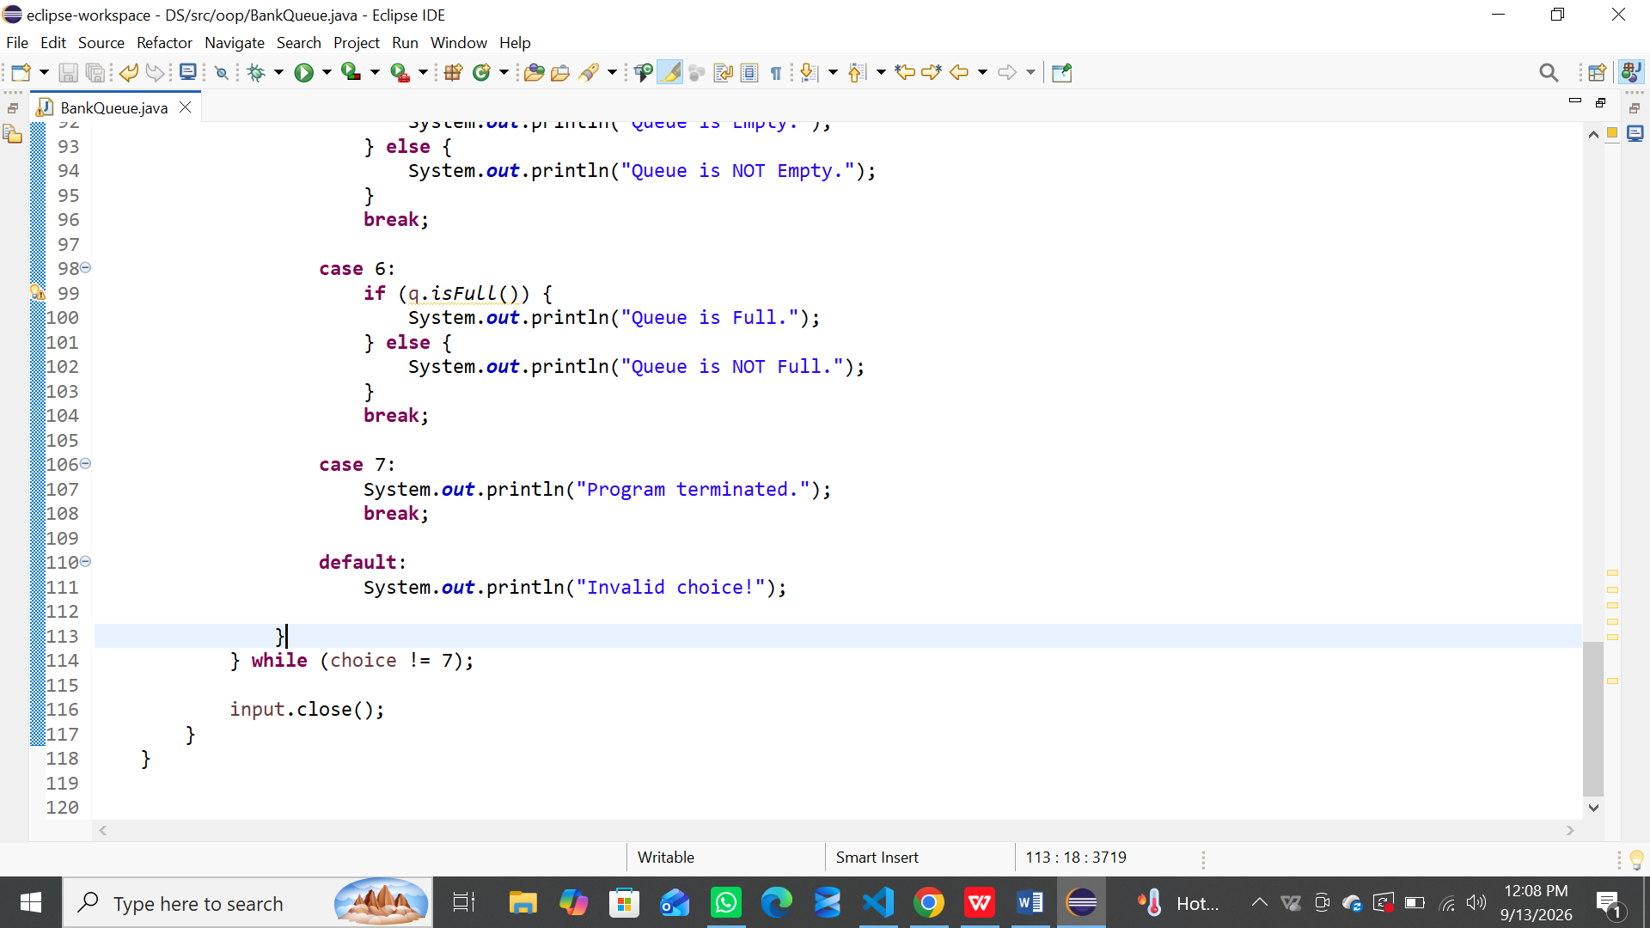
OUTPUT:
